**Marketing Campaign for Decreal Gear**

**Section 1**

**Rationale**

Decreal Gear will create content for social media providing information on fitness, training programmes and other useful advice

**Aims and Objectives**

Main Aim: Aim to increase sales by 10% over a 1-and-a-half-year period.

Ways I can do this is by using certain promotional methods such as coupons and coupons is a good method as it incises people to use them as they may provide certain

**Research**

* Primary Research

Decreal Gear conducted a survey in a town centre and they surveyed 100 people between the ages of 17-32 this test concluded that more

* Secondary Research

Researching t

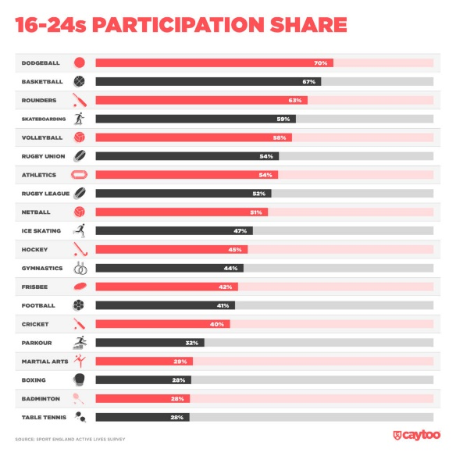

**Target Market**

My target market would be people focused on fitness and training due to that is what our products at decreal gear is targeted at the people who enjoy fitness and maybe people that also want to get into fitness and are trying to be more healthy

**Market Size and Structure**

Personally I think decreal gear is a mass market as it is isn’t specifically targeted to a certain type of people it is advertised at most people so it is advertised at a mass market and a mass amount of people due to fitness being a very popular trend in the recent years

**Trends**

The current trends in business are listed under 4 categories: Social, Ethical, Technological and Environmental. Social trends will include the trends occurring with society as a whole such as when your outside in public it could be how the people dress or how they portray themselves to the rest of society such as if someone wears a outfit that you like and you wear it then many more people start to wear it that becomes a social trend due to people copying each others styles. Etherical trends include trends that are portrayed to a certain target market such as Nike’s new Hijab range which is targeted towards Nike Hijabs are created with Muslim women's unique demands and preferences in mind, providing a sportswear option that satisfies their religious and athletic needs or is simply a new fashion trend.

**Competition**

Long-standing rivals in the fiercely competitive sports retail sector are JD Sports and Sports Direct. But Decreal Gear, a new participant, has entered the fray, escalating the conflict. The dominance of JD Sports and Sports Direct has been challenged by Decreal Gear, which has quickly risen to prominence in the sports apparel and equipment sector. Decreal Gear has succeeded in securing a sizeable portion of the market because to its cutting-edge product offers, affordable pricing, and distinctive strategy for consumer involvement. As each company competes for the attention and devotion of sports enthusiasts globally, this three-way rivalry has produced fascinating developments, from new store openings and marketing campaigns to exclusive partnerships with prominent sports companies. The rivalry between these titans of the sports retail sector is expected to intensify, ultimately bringing more options and better prices in the athletic gear market to customers.

**SWOT Analysis / PESTLE Analysis**

**Pestle Analysis:**

**Political:**

Lower Obesity Rate in the UK which reduces NHS Costs and that means spending on DG would increase as more people would be inclined to buy sports gear.

**Product Life Cycle**

The product life cycle currently of decreal gear is on its growth section of the product life cycle as the company aims to increase its sales by 21% which shows how its in the growth phase of the product

**Justification**

* From looking at your research both primary and secondary justify why there should be a campaign for this product / service

**Reliability and Validity of Information researched**

* What is your sampling method for your primary research (Survey / Questionnaire)
* List your websites for your secondary research
* Make a statement that the research you carried out is from valid, reliable etc. sources / websites

**Section 2**

**Marketing Mix / Extended 7Ps**

1. Product – The Product that decreal gear would sell is trainers which would be packaged in a box Decreal gear would sell sportswear trainers to keep on brand with the sports genre that decreal gear is in They would also sell sports clothing such as branded decreal gear trousers in a high quality bag and high quality materials which will allow the products that decreal gear sells to last a long time which would build a strong customer loyalty to the brand which will hopefully make them come back and buy again after hopefully having a good experience
2. Price – On the release day of the product we will have a 1 day sale on the released product as this means that people would be more inclined to purchase on release day and hopefully tell family and friends that are interested into decreal gear after the sale is done and we raise the price to when they come and buy the product we earn more money and we can hopefully cover the cost with the product raising after the sale
3. Promotion – Decreal gear would use some of their budget for marketing on social media as this is how they can most effectively get the youth and others to see their ad as most people use social media and look at the ads on there, they could also send out a newsletter to all people that are signed up to their website
4. Place – Decreal Gear would use their shop to release the product and so as there website but if you order from the store you would get the discount for the product for the product launch and if ordered from the website the discount would be lower than the one provided in store
5. People – Employee’s will setup a queue system which would allow the store not to have a influx of people crowding and so would the website have a queue system so it doesn’t crash this is a good idea for the store to because if you are in a queue you are less likely to have fights over the product on launch day
6. Physical environment – The shop décor would have changed to match the new products design and the new product would be on display at the front of the store to allow the customers to see the product in person before making their purchase
7. Processes – The process would be it will be manufactured with high quality manufacturing materials

**Marketing message**

**Decreal Gear Sports is for everyone.**

**Selection of Media**

**Decreal Gear would use social media to advertise there products as personally this is the most effective way to advertise to youth and other young adults as most of them have social media and a phone which means it would get loads of impressions by users and would more likely to see this but this could become costly and paying influencers and Instagram youtube and other social media ad fees can rack up to a lot of money So we would also use a free method of advertising such as email ads and we would also probably setup google ads which allows us to target the correct people using there personalised ads which allows us to advertise to people who are interested in the products that decreal gear sells which will help us get more customers because people who are interested in decreal gears products and others like it will get advertised it and this will also maximise the amount of people who purchase from decreal gear as it will most likely appeal to them because of the personalised advertising that google ads and social media apps have I would also probably let people know that come to decreal gear by putting up posters around the store and in the shop windows and putting banners on the website to show online shoppers about the deal too**

**Campaign Budget**

**£20,000 will be the allocated amount and half this budget will be allocated to social media ads as personally I think this is the best way to advertise and the best use of the money because this will allow us to promote every month on social media this is displayed in the gaant chart as this will be the best possible way to get reach to people as you can use the websites personalised advertising features which allows us to get the best impressions and the most return on investment but we would also may put some of our budget into posters to put up around the area Decreal Gear operates we could also maybe buy some ad space on London Transport which could also get us some publicity because people that are travelling on the trains and buses will look at the adverts that are displayed around the area and if they are interested they will hopefully look at the ad and check us out and this allows us to gain some more publicity**

**Timescale**